Data

We get the data from FRED and with simple formating we start to create our analise data.

We add a column with name of period two divide our data to for different periods, considering Phillips Curve validity is generally limited in definite periods

Here is how it looks like our data:

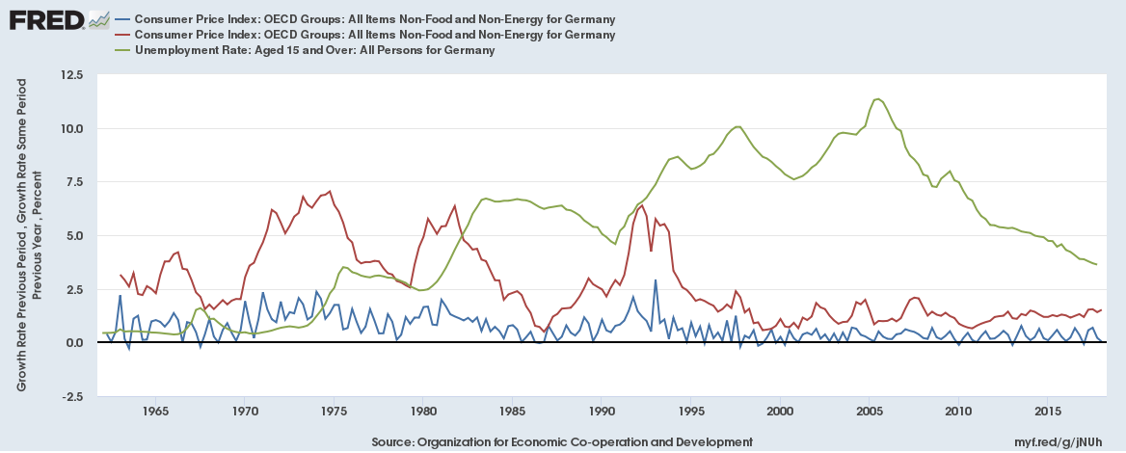

Definitons:

inf_1 is quarterly inflation rate from last quarter and

inf_2 is quarterly inflation rate from one year ago

Model reasoining:

In our analize, we use generally time series.

We checked some lagged impact of our varibales,

Decomposed their seasonality when it is necessary,

Did some F-test to see if multi lags are meaningful together,

And checked if some series of our data set is stationary or not to detect auto correlation problems

R result:

reg1=lm(inf_2 ~ un, data = dat)

summary(reg1)

Estimate Std. Error t value Pr(>|t|)

(Intercept) 4.13633 0.19755 20.938 < 2e-16 ***

un -0.27911 0.03236 -8.625 1.33e-15 ***

---

Signif. codes: 0 ‘***’ 0.001 ‘**’ 0.01 ‘*’ 0.05 ‘.’ 0.1 ‘ ’ 1

Residual standard error: 1.502 on 218 degrees of freedom

Multiple R-squared: 0.2544, Adjusted R-squared: 0.251

F-statistic: 74.4 on 1 and 218 DF, p-value: 1.332e-15

anlamlı, negatif (makro teori ile uyumlu)

in conventinal old form of phillips curve

we can detect really a negative correlation between unemployment and inflation

even without any lagged impact of unemployment

but our data is not seasonally adjusted, lets deseason inflation

and unemployment data, first

un_ts = ts(dat$un, start = c(1963,1), frequency = 4)

inf_1_ts = ts(dat$inf_1, start = c(1963,1), frequency = 4)

inf_2_ts = ts(dat$inf_2, start = c(1963,1), frequency = 4)

we used additive method since they already are percentual growth rates

does not show any explorential growth over time

comp_un = decompose(un_ts, "additive")

comp_inf1 = decompose(inf_1_ts, "additive")

comp_inf2 = decompose(inf_2_ts, "additive")

plot(comp_un)

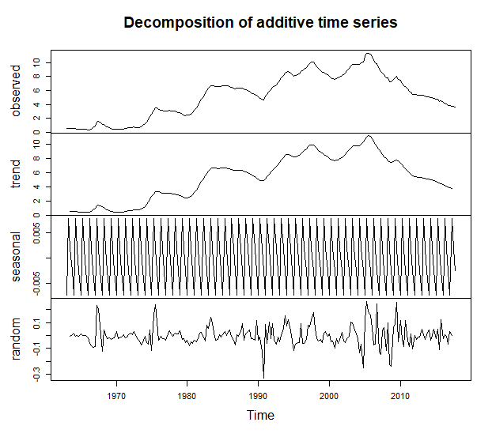

plot(comp_inf2)

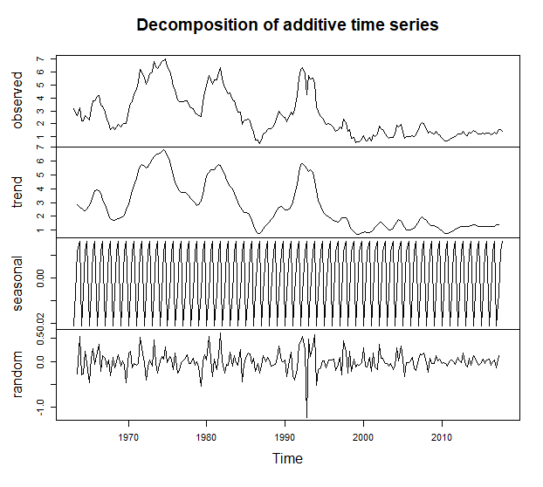

here we are seasonally adjusting our time series

un = un_ts - comp_un$seasonal

inf1 = inf_1_ts - comp_inf1$seasonal

inf4 = inf_2_ts - comp_inf2$seasonal

adding also period column

per = dat$period

dat_tmp = cbind(inf1,inf4,un,per)

dat_ts = ts(dat_tmp, start = c(1963,1), frequency = 4)

now we have adjusted time data

lets try without season effect if we still observe same relation

reg2 = dynlm(data=dat_ts, inf4 ~ un)

summary(reg2)

Estimate Std. Error t value Pr(>|t|)

(Intercept) 4.13646 0.19755 20.939 < 2e-16 ***

un -0.27913 0.03236 -8.626 1.32e-15 ***

---

Signif. codes: 0 ‘***’ 0.001 ‘**’ 0.01 ‘*’ 0.05 ‘.’ 0.1 ‘ ’ 1

Residual standard error: 1.502 on 218 degrees of freedom

Multiple R-squared: 0.2545, Adjusted R-squared: 0.2511

F-statistic: 74.41 on 1 and 218 DF, p-value: 1.325e-15

yes, quite same numbers occured

our coefficent in longh term is -0,28

Now, we are managing to explain about 15 percent of inflation's changments

by unemployment rates

lets check if we see some significant impact of different periods

dat_p1 = subset(dat_ts, per == 'period_1')

dat_p1 = ts(dat_p1, start = c(1963,1), frequency = 4)

dat_p2 = subset(dat_ts, per == 'period_2')

dat_p2 = ts(dat_p2, start = c(1973,2), frequency = 4)

dat_p3 = subset(dat_ts, per == 'period_3')

dat_p3 = ts(dat_p3, start = c(1984,1), frequency = 4)

dat_p4 = subset(dat_ts, per == 'period_2')

dat_p4 = ts(dat_p4, start = c(2007,4), frequency = 4)

reg3 = dynlm(data=dat_p1, inf4 ~ un)

summary(reg3)

Estimate Std. Error t value Pr(>|t|)

(Intercept) 4.2609 0.5063 8.416 2.66e-10 ***

un -1.3660 0.7042 -1.940 0.0597 .

---

Signif. codes: 0 ‘***’ 0.001 ‘**’ 0.01 ‘*’ 0.05 ‘.’ 0.1 ‘ ’ 1

Residual standard error: 1.358 on 39 degrees of freedom

Multiple R-squared: 0.08799, Adjusted R-squared: 0.06461

F-statistic: 3.763 on 1 and 39 DF, p-value: 0.05966

R square is too small. there is a highly significant intercept

which we can comment as sucj-h period, the inflation ratew were arround some

definite levels and not changing too much

we have negative correlation between unemployment and inflation

but loosing its significancy below %5 percent level

lets check for other periods

reg4 = dynlm(data=dat_p2, inf4 ~ un)

summary(reg4)

(Intercept) 5.8387 0.4568 12.780 6.9e-16 ***

un -0.3269 0.1259 -2.595 0.013 *

reg5 = dynlm(data=dat_p3, inf4 ~ un)

summary(reg5)

(Intercept) 4.30419 0.63728 6.754 1.23e-09 ***

un -0.28447 0.07881 -3.610 0.000496 ***

Multiple R-squared: 0.1229, Adjusted R-squared: 0.1135

best correlation, but still small R square

our coefficent is about -0.28 which is not so high

but so meaningful

reg6 = dynlm(data=dat_p4, inf4 ~ un)

summary(reg6)

(Intercept) 5.8387 0.4568 12.780 6.9e-16 ***

un -0.3269 0.1259 -2.595 0.013 *

As we see, in each period we have different intercept,

which points to differentunemployment and inflation equilibrium

and we see (as negative) higher coefficents compare to the regression

where we used all data as whole

so we can think in Germany, inflation rates were even more elastical to

the employment levels

what about lagged impact of unemployment? Since teory tells a process

beyond the phillips model, where the wages would play an intermediate role

we choose to focus on third period, where we found more correlation

between infation and unemployment

reg7 = dynlm(data=dat_p3, inf4 ~ L(un, c(10)))

summary(reg7)

Estimate Std. Error t value Pr(>|t|)

(Intercept) 7.27439 0.53095 13.70 < 2e-16 ***

L(un, c(10)) -0.68272 0.06803 -10.04 5.57e-16 ***

Multiple R-squared: 0.5482, Adjusted R-squared: 0.5428

after many trial we noticed that all lags, alone were significant

and all of the lags between fifth and fifteenth lags were giving both

higher t values and R squares

but they are not meaningfull together

why?

lets try with quarter to quarter inflation changment data

reg8 = dynlm(data=dat_p3, d(inf1) ~ L(un, c(7,8,9,10)))

summary(reg8)

Estimate Std. Error t value Pr(>|t|)

(Intercept) -0.06766 0.27900 -0.242 0.809013

L(un, c(7, 8, 9, 10))7 -0.66370 0.33381 -1.988 0.050203 .

L(un, c(7, 8, 9, 10))8 2.00171 0.61524 3.254 0.001671 **

L(un, c(7, 8, 9, 10))9 -2.33666 0.61853 -3.778 0.000303 ***

L(un, c(7, 8, 9, 10))10 1.01043 0.34535 2.926 0.004469 **

---

Signif. codes: 0 ‘***’ 0.001 ‘**’ 0.01 ‘*’ 0.05 ‘.’ 0.1 ‘ ’ 1

Residual standard error: 0.4964 on 80 degrees of freedom

Multiple R-squared: 0.1681, Adjusted R-squared: 0.1265

F-statistic: 4.042 on 4 and 80 DF, p-value: 0.0049

this was one of the best regression which returned all significant t values for

unemployment levels lagged effect

but they have all different signs

are they compoundly meaningfull?

library(car)

linearHypothesis(reg8, c("L(un, c(7, 8, 9, 10))7+ L(un, c(7, 8, 9, 10))8

+L(un, c(7, 8, 9, 10))9+ L(un, c(7, 8, 9, 10))10 "))

Model 1: restricted model

Model 2: d(inf1) ~ L(un, c(7, 8, 9, 10))

Res.Df RSS Df Sum of Sq F Pr(>F)

1 81 19.740

2 80 19.714 1 0.026715 0.1084 0.7428

unfortunetly they are not meaningfull together

means no need to sum up their coefficents to derive a total

coefficent to consider as lagged impact of unemployment changes on inflation changes

lets try whole adjusted data set with lagged impact of unemployment

reg9 = dynlm(data=dat_ts, d(inf1) ~ L(un, c(8,9,10)))

summary(reg9)

Estimate Std. Error t value Pr(>|t|)

(Intercept) -0.01022 0.06674 -0.153 0.87848

L(un, c(8, 9, 10))8 0.41978 0.20629 2.035 0.04314 *

L(un, c(8, 9, 10))9 -0.97828 0.37721 -2.593 0.01018 *

L(un, c(8, 9, 10))10 0.56024 0.20506 2.732 0.00684 **

---

Signif. codes: 0 ‘***’ 0.001 ‘**’ 0.01 ‘*’ 0.05 ‘.’ 0.1 ‘ ’ 1

Residual standard error: 0.4908 on 206 degrees of freedom

Multiple R-squared: 0.03516, Adjusted R-squared: 0.02111

F-statistic: 2.503 on 3 and 206 DF, p-value: 0.0604

we tried many versions and

this regression seems the best but

too small R square and different signs

linearHypothesis(reg9, c("L(un, c(8, 9, 10))8

+L(un, c(8, 9, 10))9+ L(un, c(8, 9, 10))10 "))

Model 1: restricted model

Model 2: d(inf1) ~ L(un, c(8, 9, 10))

Res.Df RSS Df Sum of Sq F Pr(>F)

1 207 49.634

2 206 49.628 1 0.0063628 0.0264 0.8711

once again, they are not meaningful together

we showed that, expectation augmented model was not helpful but

classical one worked fine on Germany's quarterly data set

but we didn't care about stationarity

lets examine it

library(fpp)

adf.test(un_ts)

Augmented Dickey-Fuller Test

data: un_ts

Dickey-Fuller = -0.82653, Lag order = 6, p-value = 0.958

alternative hypothesis: stationary

p value is not below 5% so;

un_ts time series is not derived from a unique root

we dont have a stationary time series which means

our regressions will not be biased

after checking if other two time series are also not stationary

adf.test(inf_1_ts)

Dickey-Fuller = -3.5789, Lag order = 6, p-value = 0.0363

alternative hypothesis: stationary

oops, we have a stationary data set here

we have auto-correlation till 6th lagged term of inflation from

one quarter ago

so we need to model our regressions with inf1

with their at least six lags!

adf.test(inf_2_ts)

Dickey-Fuller = -4.0562, Lag order = 6, p-value = 0.01

alternative hypothesis: stationary

same is true for time series of quarterly inflation from

one year ago

so we try our chance to check out another classical phillips curve model

which is auto correlated

reg10 = dynlm(data = dat_p2, inf4 ~ un + L(inf4, c(1,2,3,4,5,6)))

summary(reg10)

Estimate Std. Error t value Pr(>|t|)

(Intercept) 0.73154 0.28816 2.539 0.01675 *

un -0.05668 0.04735 -1.197 0.24100

L(inf4, c(1, 2, 3, 4, 5, 6))1 1.37541 0.16671 8.250 4.27e-09 ***

L(inf4, c(1, 2, 3, 4, 5, 6))2 -0.50613 0.25918 -1.953 0.06055 .

L(inf4, c(1, 2, 3, 4, 5, 6))3 0.27070 0.25121 1.078 0.29010

L(inf4, c(1, 2, 3, 4, 5, 6))4 -0.74987 0.25572 -2.932 0.00651 **

L(inf4, c(1, 2, 3, 4, 5, 6))5 0.91586 0.26806 3.417 0.00190 **

L(inf4, c(1, 2, 3, 4, 5, 6))6 -0.43073 0.15618 -2.758 0.00996 **

---

Signif. codes: 0 ‘***’ 0.001 ‘**’ 0.01 ‘*’ 0.05 ‘.’ 0.1 ‘ ’ 1

Residual standard error: 0.349 on 29 degrees of freedom

Multiple R-squared: 0.9271, Adjusted R-squared: 0.9094

F-statistic: 52.65 on 7 and 29 DF, p-value: 8.743e-15

so hi R square!

coefficent of unemployment is still negative

it is now smaller

and lost its significancy

linearHypothesis(reg10, c("

L(inf4, c(1, 2, 3, 4, 5, 6))1 + L(inf4, c(1, 2, 3, 4, 5, 6))2 + L(inf4, c(1, 2, 3, 4, 5, 6))3 +

L(inf4, c(1, 2, 3, 4, 5, 6))4 + L(inf4, c(1, 2, 3, 4, 5, 6))5 + L(inf4, c(1, 2, 3, 4, 5, 6))6

"))

Model 1: restricted model

Model 2: inf4 ~ un + L(inf4, c(1, 2, 3, 4, 5, 6))

Res.Df RSS Df Sum of Sq F Pr(>F)

1 30 33.232

2 29 3.532 1 29.7 243.85 1.185e-15 ***

yes the lags are meaningful!

so, we notice that we over estimated our coefficent in reg4

but we know that in periods before, the inflation rates were correlated by such periods

unemployment rate from reg4

so how to check the direction of the relation?

as a last regression lets use our best-fit period

p3, which is between two crises

reg11 = dynlm(data = dat_p3, inf4 ~ un + L(un, c(1,2,3,4,5,6)) + L(inf4, c(1,2,3,4,5,6)))

summary(reg11)

Estimate Std. Error t value Pr(>|t|)

(Intercept) 0.60617 0.33792 1.794 0.076873 .

un -0.32339 0.27163 -1.191 0.237580

L(un, c(1, 2, 3, 4, 5, 6))1 0.62216 0.50788 1.225 0.224398

L(un, c(1, 2, 3, 4, 5, 6))2 -0.01152 0.51633 -0.022 0.982259

L(un, c(1, 2, 3, 4, 5, 6))3 -0.64488 0.54930 -1.174 0.244103

L(un, c(1, 2, 3, 4, 5, 6))4 0.44167 0.56901 0.776 0.440070

L(un, c(1, 2, 3, 4, 5, 6))5 -0.39731 0.58540 -0.679 0.499423

L(un, c(1, 2, 3, 4, 5, 6))6 0.26210 0.32143 0.815 0.417416

L(inf4, c(1, 2, 3, 4, 5, 6))1 1.13455 0.10921 10.389 3.57e-16 ***

L(inf4, c(1, 2, 3, 4, 5, 6))2 -0.06415 0.15298 -0.419 0.676186

L(inf4, c(1, 2, 3, 4, 5, 6))3 -0.19030 0.15057 -1.264 0.210188

L(inf4, c(1, 2, 3, 4, 5, 6))4 -0.24960 0.14648 -1.704 0.092527 .

L(inf4, c(1, 2, 3, 4, 5, 6))5 0.59076 0.14793 3.993 0.000151 ***

L(inf4, c(1, 2, 3, 4, 5, 6))6 -0.31633 0.10355 -3.055 0.003118 **

---

Signif. codes: 0 ‘***’ 0.001 ‘**’ 0.01 ‘*’ 0.05 ‘.’ 0.1 ‘ ’ 1

Residual standard error: 0.4254 on 75 degrees of freedom

Multiple R-squared: 0.9219, Adjusted R-squared: 0.9084

F-statistic: 68.09 on 13 and 75 DF, p-value: < 2.2e-16

But all the significancies of unemployment levels are lost

while the the lags of inflation itself, is much more better explaining

our current inflation.

Conclusion:

Validity of Phillips Curve seems to hold for Germany both in general, and also in sub periods, but relatively smaller coefficents arround -0,2 and -0.3

In different period such elasticity is changing a lot.

But when we tried to examine Expectation Augmented Phillips Curve,

We couldn’t get same strong relation between unemployment and inflation.

One reason always can be also about our naive expectation assumption that we considered expectations are always equal to last observation.

We showed that in conventional – classical form of Phillips Curve, even such strong correletaion is not a cause-effect relationship.

Literaly; we can say Phillips Curve is valid in Germany but, unemployment rates are not defining inflation rates.

Inflation rates are looks like enough sticky over all period that we examined, where main explanatory variable were its own lags with so high R squares.

end